Michał Myck, CenEA
May 2025

The Polish Presidential Elections 2025: Can the Democratic Coalition Complete Their 2023 Victory?

It is safe to say that the outcome of the second round of the Polish presidential elections, scheduled for June 1, 2025, will determine the potential for significant structural reforms in the country in the coming years. The two candidates are: Karol Nawrocki, officially declared as a ‘civic candidate’ (though for all practical purposes associated with the previous government’s Law and Justice party, Prawo i Sprawiedliwość – PiS), and Rafał Trzaskowski representing the main coalition party in the current government, the Civic Platform (Platforma Obywatelska), which won the Polish parliamentary elections in October 2023. In the first round of the 2025 presidential election, which took place on May 18, 2025, Rafał Trzaskowski came first with 31.4 percent of the votes and Karol Nawrocki second with 29.5 percent. This policy brief explores the mechanisms through which the Polish President can influence current policy, using past economic initiatives as illustrative examples. It also examines the results of the first round of the election in greater depth and highlights key areas where reforms would likely face significant obstacles, were Karol Nawrocki to win the decisive second round.

What Can the Polish President Do?
Although elected in a popular vote, the Polish President’s power in terms of influence on policies is highly limited. The President acts as the Supreme Commander of the Armed Forces of the Republic of Poland and is officially responsible for representing Poland on the international arena. However, most of the executive power in Poland lies with the government, which in turn requires the support of the Parliament.
That said, the past ten years of Polish politics—the years under the outgoing President Andrzej Duda—have shown that a government with only a narrow parliamentary majority can be highly dependent on the President. Its effectiveness may be either enhanced by a cooperative President or significantly constrained through the use of the presidential veto on legislative initiatives.
Andrzej Duda, who was picked as a surprise candidate to represent the Law and Justice party—in a similar manner to Karol Nawrocki today— won the elections in 2015. He facilitated a series of destructive reforms in the areas of the judiciary, education, and the labor market in the years Law and Justice party headed the government; later he blocked many of the current government’s efforts to reverse those policies.
The outcome of the vote on June 1, 2025, will therefore be crucial for the prospects of a clear return to democratic standards in Poland, and for the deeper structural reforms needed to place the Polish economy on a long-term development path. The winning candidate will also either facilitate coordinated efforts in international policy and joint European initiatives, or act to obstruct the current government’s actions in this area—including key policies related to support for Ukraine.

The President’s Influence on Economic Policy: Electoral Promises vs. Implementation
The limited executive power of the Polish President does not stop the candidates from coming forward with rich electoral programmes. These cover many areas outside of the President’s direct sphere of influence, including economic policies.
Using Andrzej Duda’s presidency as an example, it seems that while some of these are eventually implemented (although typically not without political frictions involving the Parliament) others tend to be more of electoral slogans than areas of real concern:
In 2015, Andrzej Duda campaigned on two major economic initiatives: lowering the retirement age and substantially increasing the main income tax allowance. In the first case, he came forward with a legislative proposal to the Parliament almost immediately after being elected, aimed at restoring the lower retirement age of 60 for women and 65 for men. Although the government had campaigned on the same reform before taking office, the Parliament froze Duda’s initiative for a year in an effort to introduce less drastic changes to pension eligibility criteria. Eventually, political considerations and the weight of the 2015 electoral promises prevailed. As a result, Poland is the only EU country with as big as a five-year gap in the retirement age between men and women. The electoral tax reduction proposal was, however, quickly abandoned. As shown in a recent commentary (Myck et al. 2025a), Duda not only failed to deliver on this promise but, over his ten-year presidency, largely ignored tax policy altogether—both in terms of initiating legislation and engaging in public debate on fiscal matters.
Initiatives by earlier presidents also show that while Polish presidents are always dependent on the Parliament, they can exert some influence over economic policy. For example, Bronisław Komorowski (in office 2010-2015) put forward a legislative initiative to change tax regulations for families with children, which the government later took on board. While the government’s implemented regulations differed from Komorowski’s proposal, they were still in line with his objectives (Myck et al. 2013).
These examples clearly illustrate that the success of any initiative from the president’s office ultimately depends on the parliamentary majority the President is able to mobilize. Based on the electoral promises of this year’s top candidates, such a majority seems highly unlikely regarding one of the major electoral promises of Law and Justice’s candidate, Karol Nawrocki. Nawrocki has proposed a substantial income tax reduction for families with 2 or more children, designed in a way that would heavily benefit the richest families (Myck et al. 2025b). The reform is estimated to cost about 19bn PLN (0.5 percent of GDP) per year, with over 60 percent of the total amount benefiting families in the top income quintile. Such a measure is extremely unlikely to gain support not only from the current government, but also—given its distributional consequences—from within Nawrocki’s own political base. One way to interpret this is that much like the deep tax cuts proposed by Andrzej Duda in 2015, Nawrocki’s tax proposal bears the hallmarks of a simple and appealing campaign slogan that is likely to be forgotten, whether or not he wins the election.

The First Round Results and Final Vote Prospects
While Rafał Trzaskowski placed first in the initial round of voting on May 18, 2025, the difference between the top two candidates came down to only 1.8 percentage points. This suggests a very close race in the second round and intensive electoral campaigning in the days leading up to the election. How close the runoff will be depends on the split of votes among those who supported other candidates in the first round, as well as their participation levels in the second round.
In the first round the top seven candidates collected 96.1 percent of the votes in total. Two candidates representing the current coalition parties received 5.0 percent (Szymon Hołownia) and 4.2 percent (Magdalena Biejat) of the votes, respectively. Two other main right-wing candidates collected a combined 21.2 percent: Sławomir Mentzen (Konfederacja party) received 14.8 percent, and Grzegorz Braun (Wolność party) received 6.3 percent. Adrian Zandberg, representing the left-wing opposition (Razem party), received 4.9 percent.
If those who voted for the government coalition candidates fully shift their votes to Trzaskowski in the second round, he could count for about 40.6 percent of the vote – still far short of the necessary majority. To secure the win, he would need to collect some support from both the left and the right. However, it is unlikely that voters in either of these cases unilaterally shift support to one of the top candidates.
As shown in Figure 1 below the main candidates will have to make strong appeals to the youngest voters (aged 18-29), the majority of whom supported Mentzen (34.8 percent) and Zandberg (18.7 percent). Trzaskowski is more likely to attract support from women and better educated voters. Based om the results of the first round, Nawrocki, can count on voters with less than tertiary education and on slightly more votes from men. While Biejat and Hołownia have already publicly endorsed Trzaskowski, the other candidates have so far refrained from making any declarations of support.
The public debate ahead of the second round is likely to focus on military and economic security, migration and support for Ukraine (including its refugee population in Poland). The final round of the 2025 presidential race in Poland is likely to be extremely close and highly polarising.

Figure 1. Poll results from the first round in the Polish Presidential Elections 2025,
by demographics
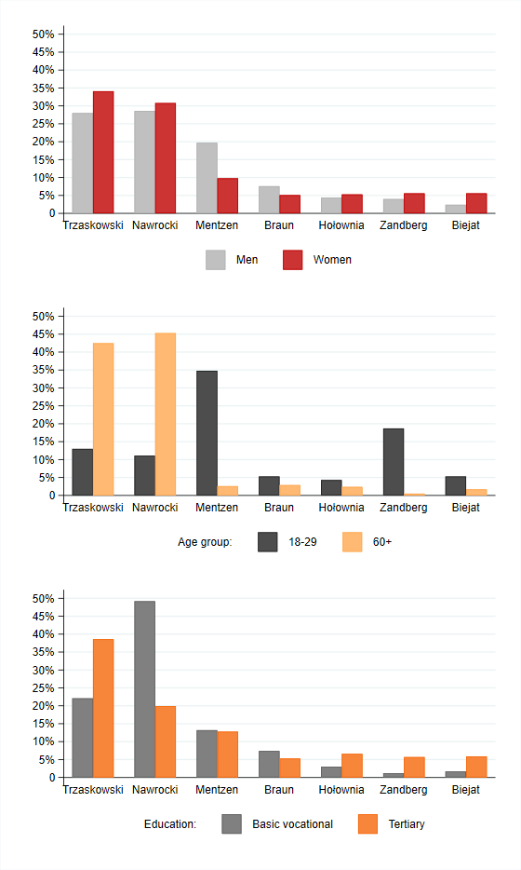
Source: TVP info. Note: Late poll results by IPSOS, based on the results from 90 percent of the polling stations.

Completing the 2023 Parliamentary Victory
The democratic, pro-European coalition that won a parliamentary majority in October 2023 has so far only been partly successful in restoring the rule of law and a functioning system of checks and balances after their dismantling by the previous government. Other electoral promises from 2023—such as the liberalization of abortion rules, legislation on same-sex partnerships, and reform of the public media—remain to be implemented. The government implemented some important changes in the public media and judiciary, but broader reforms were either vetoed by President Duda or postponed due to the likelihood of his opposition.
On a number of occasions Duda also used a procedure called ‘preventive control’. Under such procedure, legislation is sent to the Constitutional Tribunal before the President decides whether to sign it or not. Since the Constitutional Tribunal has been central to controversies over judicial reforms introduced by the previous government, such decisions are simply another form of delaying the implementation of new legislation. There is thus little doubt that Rafał Trzaskowski’s victory on June 1st, 2025, is essential for the current government. It would enable reforms crucial for the return of the rule of law, for bringing back the Polish legal system in line with decisions of the European Court of Justice, and for advancing other major reforms in public media, women’s and minority rights, and more. From this point of view Karol Nawrocki’s win on June 1st, 2025, is key for the parties of the previous government, to stop these fundamentally important reforms.
The current government is facing important challenges in many policy areas and effective cooperation with the new President will be fundamental. Given the current level of government debt and high budget deficits, it will have to take significant steps to consolidate public finances. At the same time, it has committed to increasing spending on healthcare and education, while maintaining one of the highest levels of military spending among NATO countries. The government must also handle the challenges of demographic ageing and migration flows – all in the context of the continuing Russian aggression in Ukraine, and the overall global uncertainly. Even with strong presidential support, tackling all these issues will be challenging. Facing them under an antagonistic Head of State—in the case of Nawrocki’s victory—would not only make the government’s task significantly harder, it with also have serious implications for medium-term political stability in Poland and potentially other European countries.

References
Myck, M., Krol, A., Oczkowska, M. (2025a) “What the President promised, what the government introduced” (“Co obiecał Prezydent, co wprowadził rząd”), CenEA Preelection Commentary 07/04/2025, in Polish.
Myck, M., Krol, A., Oczkowska, M. (2025b) “Campaign tax promises of Karol Nawrocki” (“Kampanijne deklaracje podatkowe Karola Nawrockiego”), CenEA Preelection Commentary 14/04/2025, in Polish.
Myck, M., Kundera, M., Oczkowska, M. (2013) „The President's proposal to modify family support within the Polish tax system” („Prezydencka propozycja modyfikacji wsparcia rodzin w ramach systemu podatkowego”), CenEA Commentary 06/06/2013, in Polish.

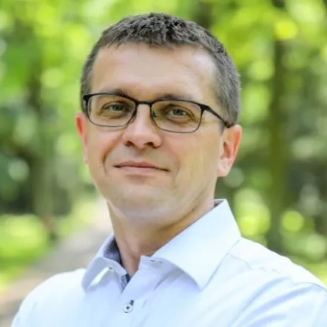

Michał Myck
Centre for Economic Analysis (CenEA)
mmyck@cenea.org.pl
www.cenea.org.pl
Michał Myck is the director of CenEA. He previously worked at the Institute for Fiscal Studies in London and at the DIW-Berlin. He received his B.A. and M.Phil. degrees at the University of Oxford (PPE – 1997, Economics – 1999), Ph.D. degree at the University of Warsaw (2006) and completed his habilitation at the Free University Berlin (2015). He is affiliated as Privatdozent at the University of Greifswald. His work focuses on labor and health economics, fiscal policy and applied micro-econometrics.

